# How to add custom fields in MailerLite:

Go to:

1. Subscribers
2. Fields.
3. Click on the green ‘Create field’

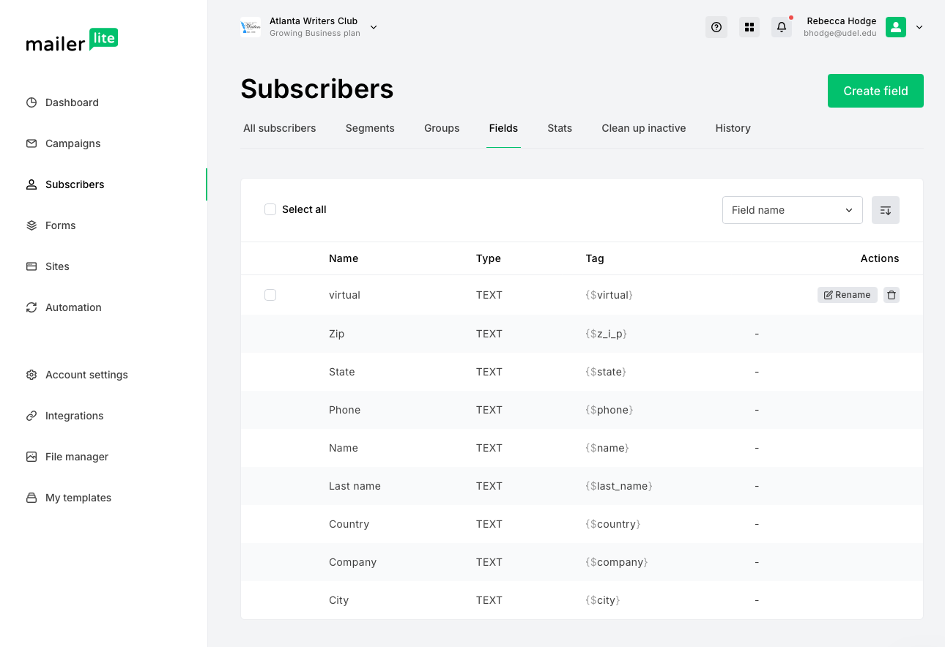

1

2

3

1. Type in the name of the variable, and choose its type (you’ll pretty much always choose ‘text’ unless it’s very explicitly a number or date). A screenshot of a computer

   Description automatically generated
2. Click okay, and it’s been added! Note that when you first create it, nobody has a value for it. See the next section for how to add in information for custom fields to your subscribers.

